**一張含有 文字, 字型, 圖形, 平面設計 的圖片

AI 產生的內容可能不正確。**

**參加者切結書**

**Liability Waiver & Assumption of Risk**

本人已詳細閱讀並同意以下條款，並承諾遵守苗栗明德水陸空遊憩區（以下簡稱「本園區」）的一切安全規範與工作人員指示：

**一、活動性質與風險**

本人理解並同意，本園區所提供的水、陸、空遊憩活動，包括但不限於：空中飛索、空中自行車、水域設施等，屬高風險冒險活動，具有導致人身傷害、死亡或財產損失之可能性。本人願自行承擔參與活動的風險。

**二、責任豁免**

在中華民國法律所允許的最大範圍內，本人放棄對於因參加上述活動所可能發生的：(1) 人身傷害或死亡，或 (2) 財產損失或損害（不包括本園區重大過失或故意行為所致），向本園區、其員工、經理、合作夥伴、代理人及承包商提出任何索賠、訴訟或賠償之權利。

**三、賠償責任**

如因本人疏忽、違規或不當行為，導致任何人身傷害、財物損失或第三方損害，本人同意負全部法律及賠償責任，並補償本園區因此支出的任何費用（包含合理律師費）。

**四、健康聲明**

本人確認身體狀況適合參與活動，無心臟病、高血壓、懷孕、氣喘、癲癇、近期手術、骨骼或關節傷害、飲酒或其他不適合參與之狀況，並已在必要時諮詢醫師意見。

**五、影像與個資同意**

本人同意本園區可於活動中拍攝本人之影像或影片，作為安全監控、紀錄用途，並依據個資法規範收集、處理及利用相關資料。

**六、適用法律與爭議解決**

本切結書以中文版本為準，受中華民國法律管轄，如有爭議，由台灣苗栗地方法院專屬管轄。

本人已完整閱讀、理解並同意本切結書之全部內容。

本人親簽：(點選此處簽名)

**簽署送出**

**一張含有 文字, 字型, 圖形, 平面設計 的圖片

AI 產生的內容可能不正確。Miaoli Mingde Water. Land. Sky Adventure Park**

**Liability Waiver & Assumption of Risk**

I have read, understood, and agree to the following terms, and will comply with all safety regulations and instructions of Miaoli Mingde Water-Land-Air Recreation Area (“the Park”):

1. **Activity Risks**  
   I understand that activities including but not limited to zipline, aerial bicycles, and other adventure activities involve inherent risks of injury, death, or property loss. I voluntarily assume all such risks.
2. **Liability Waiver**  
   To the fullest extent permitted by Taiwan (R.O.C.) law, I waive all rights to claim, sue, or seek compensation from the Park, its staff, and contractors for injury, death, or property loss arising from participation, except for cases caused by the Park’s gross negligence or willful misconduct.
3. **Indemnification**  
   I accept full responsibility for any injury, property damage, or harm to others caused by my negligence or violation of rules, and will indemnify the Park against related claims or costs.
4. **Health Declaration**  
   I am in good health and have no medical conditions (including but not limited to heart disease, high blood pressure, pregnancy, asthma, epilepsy, recent surgery, or intoxication) that may affect safe participation.
5. **Media & Data Consent**  
   I consent to the Park taking and using my photos/videos for safety, records, or promotion, and to the lawful collection and use of my personal data.
6. **Governing Law & Jurisdiction**  
   This waiver is governed by the laws of the Republic of Taiwan (R.O.C.). The Chinese version prevails, and any disputes shall be subject to the exclusive jurisdiction of Taiwan (R.O.C.) courts. I have fully read, understood, and agree to all contents of this waiver.

Name: __________________________

**簽署送出**

**一張含有 文字, 字型, 圖形, 平面設計 的圖片

AI 產生的內容可能不正確。**

**家長（監護人）同意書**

**Parental / Guardian Consent Form**

茲同意本人之子女／被監護人參加苗栗明德水陸空遊憩區（以下簡稱「本園區」）所提供的水、陸、空遊憩活動，包括但不限於：空中飛索、空中自行車、水域設施等，並確認已閱讀及理解本園區之安全規範與「參加者切結書」內容，承諾遵守工作人員指示。

**一、健康聲明**

本人已確認參加者身體狀況良好，無心臟病、高血壓、懷孕、氣喘、癲癇、近期手術、骨骼或關節傷害、飲酒或其他不適合參與之狀況，並已於必要時諮詢醫師意見。

**二、責任承擔**

本人了解活動之高風險性質，並同意代表參加者承擔法律允許範圍內之風險與責任，除非因本園區重大過失或故意行為所致，否則放棄向本園區及其相關人員提出任何索賠或訴訟之權利。

**三、影像與個資同意**

本人同意本園區可於活動中拍攝參加者之影像或影片，作為安全監控、紀錄用途，並依據個資法規範收集、處理及利用相關資料。

我已充分理解並同意上述條款，並願以父母、法定監護人或其他合法身份負責參加者之安全與行為。

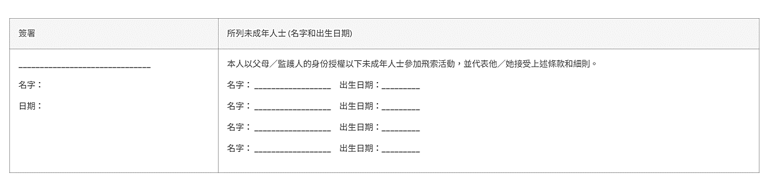

**一張含有 文字, 字型, 圖形, 平面設計 的圖片

AI 產生的內容可能不正確。**

**Miaoli Mingde Water. Land. Sky Adventure Park**

**Parental / Guardian Consent Form**

I hereby consent to my child/ward’s participation in the water, land, and aerial activities provided by the Miaoli Mingde Water. Land. Sky Adventure Park (hereinafter referred to as “the Park”), including but not limited to zipline, aerial bicycles, floating platforms, and other adventure activities.

I have read and understood the Park’s safety regulations and the “Participant Waiver & Release of Liability” and undertake to ensure compliance with all instructions given by Park staff.

**1. Health Declaration**

I confirm that the participant is in good health, with no medical conditions such as heart disease, high blood pressure, pregnancy, asthma, epilepsy, recent surgery, bone or joint injuries, intoxication, or any other conditions unsuitable for participation. I have consulted a physician if necessary.

**2. Liability Acceptance**

I understand the high-risk nature of the activities and, on behalf of the participant, agree to assume the risks and responsibilities to the fullest extent permitted by law. I waive any rights to claim, sue, or seek compensation from the Park and its personnel, except where caused by gross negligence or willful misconduct.

**3. Media & Personal Data Consent**

I consent to the Park taking photographs or videos of the participant during the activities for safety monitoring, recordkeeping. I also consent to the collection, processing, and use of the participant’s personal data in accordance with applicable laws.

I have fully understood and agreed to the above terms, and I accept full responsibility for the participant’s safety and conduct during the activities.